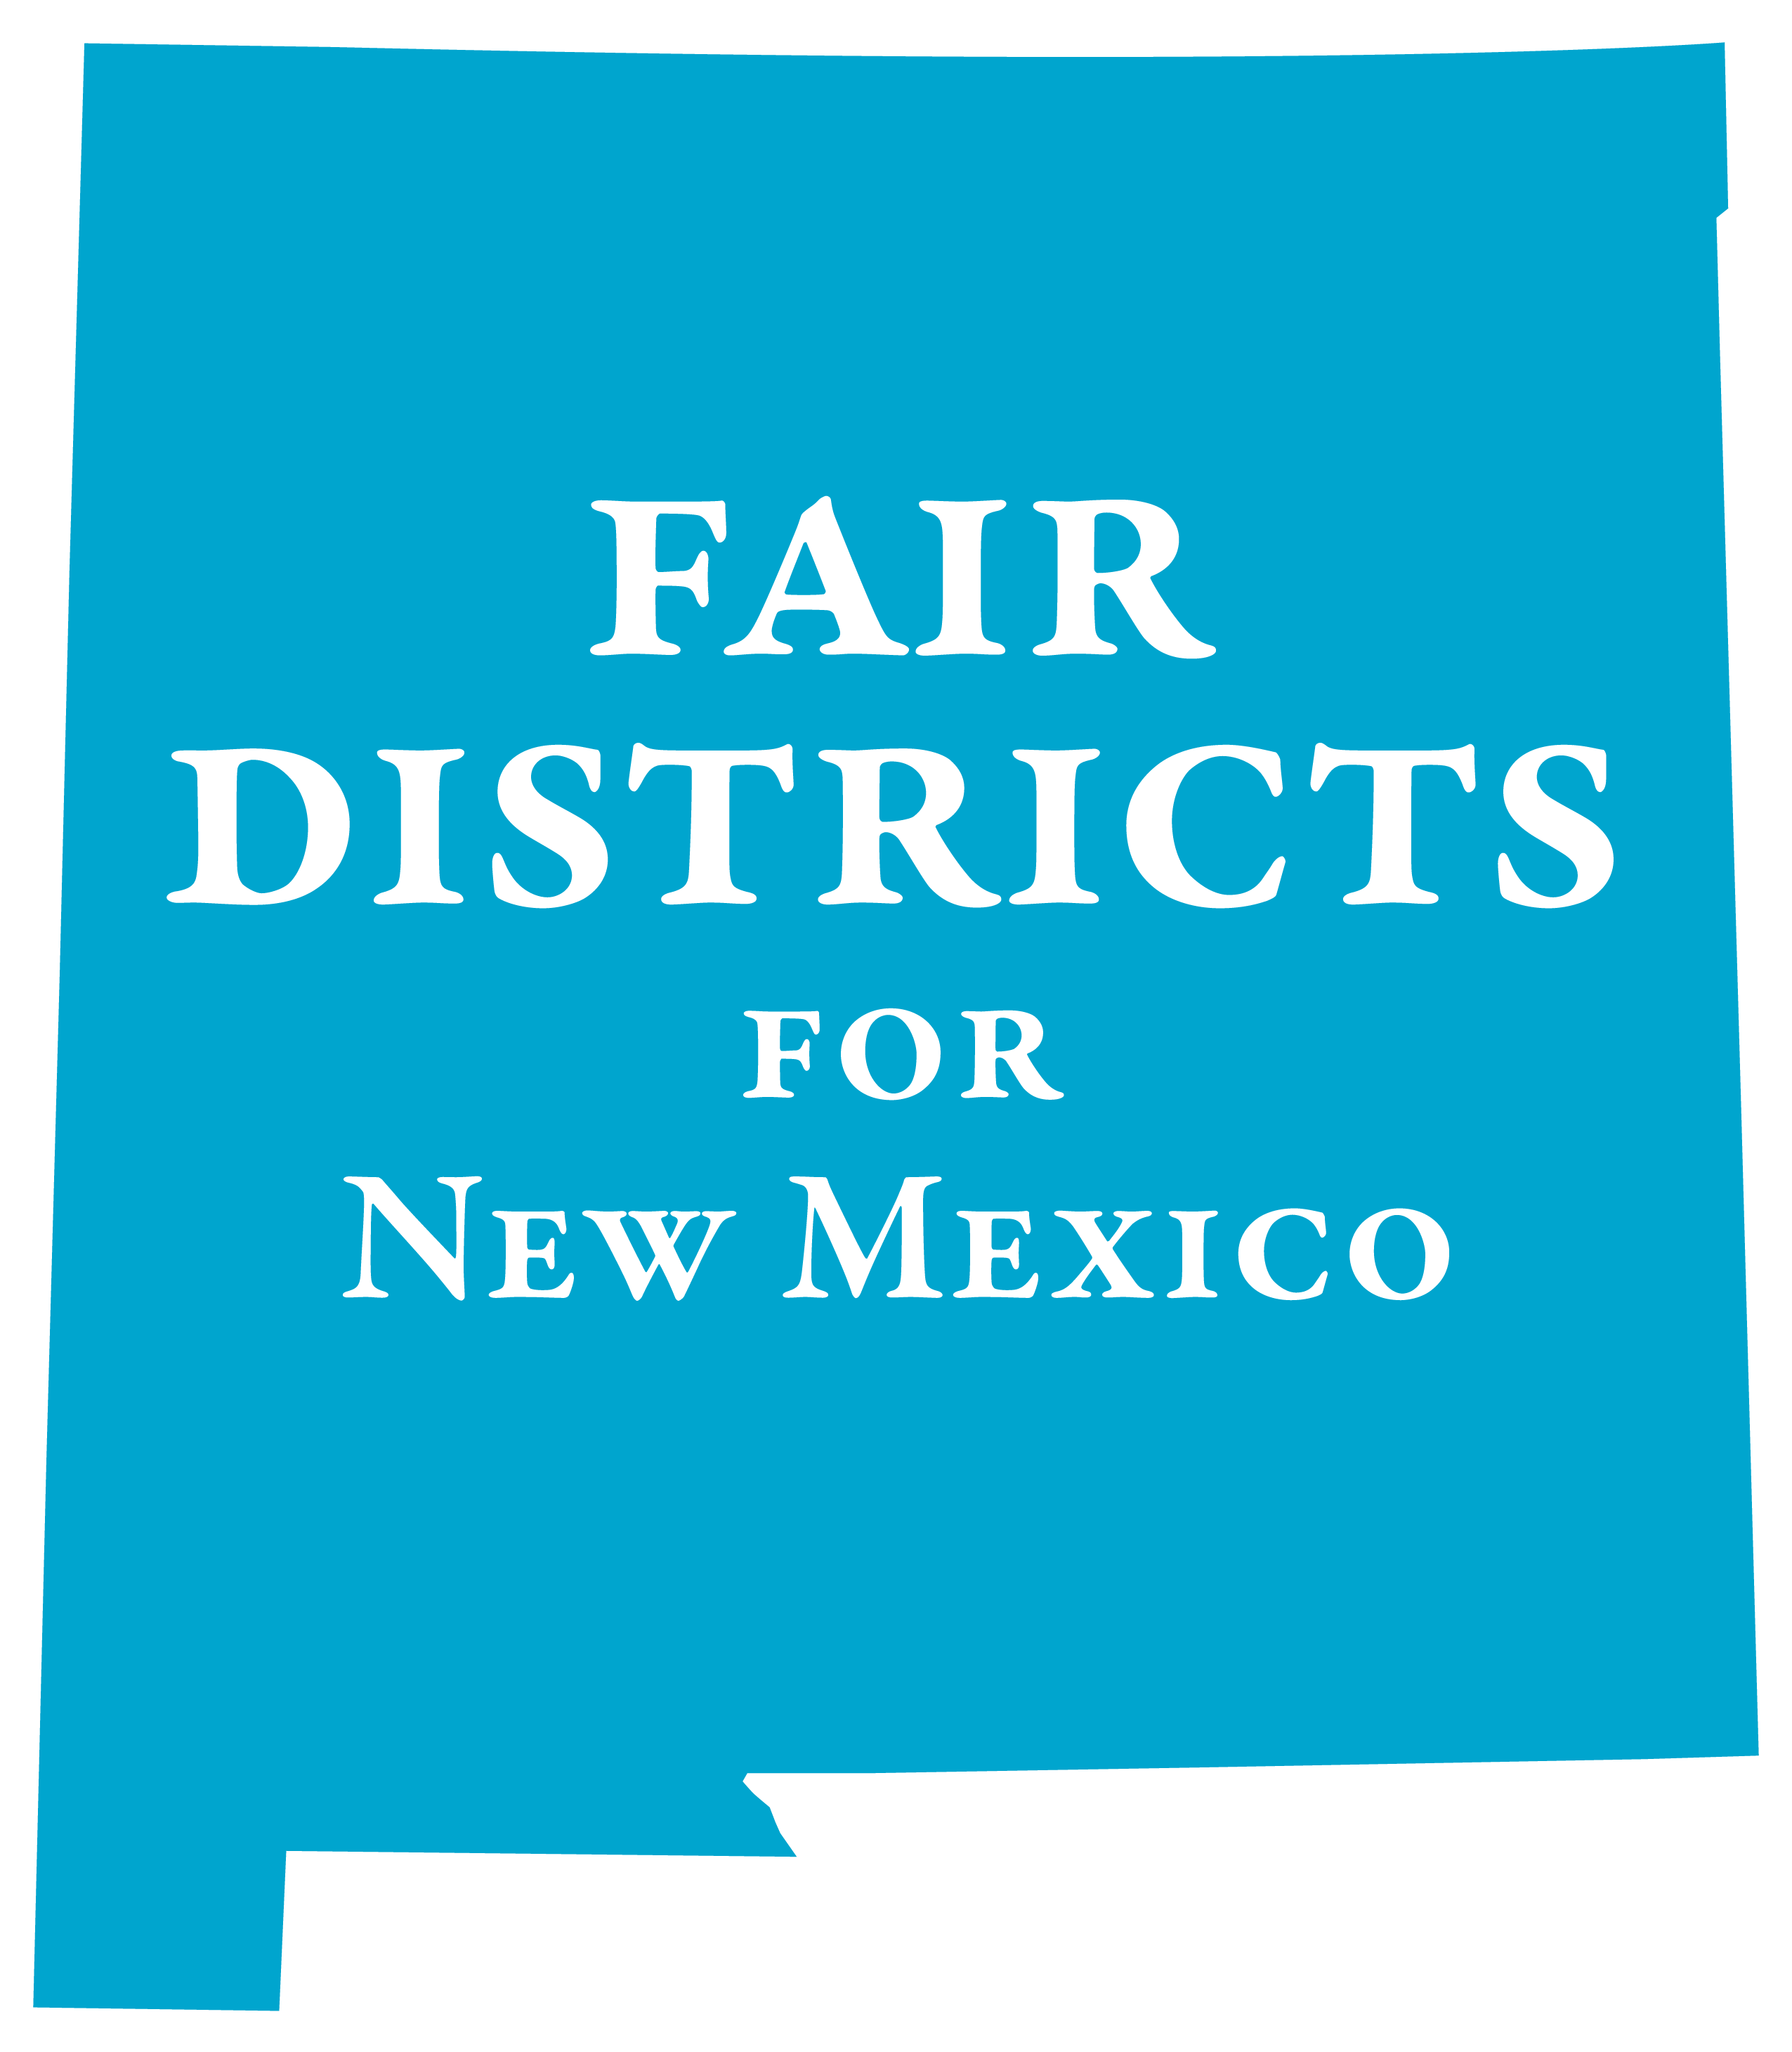
FAIR DISTRICTS FOR NEW MEXICO PROJECT (FDNM)
Inviting organizations to join with us to advocate for fair, transparent
and accountable redistricting following the 2020 census

Name of the Organization: ____________________________________________________________
Address____________________________________________________________________________
City_____________________________________ State______________ Zip_____________________
Designated contact person______________________________________________________________
Email______________________________________ phone _________________________________

____ FDNM can list you as a supporter on our website & publicity
____ We want to receive regular updates on the project – we promise not too many
____ We want to be part of the FDNM Project working group
____ We can contact legislators to educate them about fair redistricting
____ Other – please explain

Website: www.fairdistrictsnm.org
Project Contacts:
Dick Mason: act@lwvnm.org; 505-239-3804
Kathleen Burke; fairdistricts@lwvnm.org; 505-907-5355Mail:
Mail: c/o LWVNM, Suite F-6, 2315 San Pedro, Albuquerque, NM 87110

