Ask Democratic Candidates to Support the Democratic Platform

and vote for the 2023 House Joint Resolution to put the question of creation of an independent redistricting commission on the ballot of the 2024 general election.
Let the voters decide!

The 2022 Democratic Party NM Platform, plank on Redistricting states:

“We will advocate for a constitutional amendment to end gerrymandering by creating and giving authority to an independent non-partisan redistricting commission that includes diverse membership, specifically including Native American representation and participation. This commission shall be separate from the legislative process to prevent the drawing of political boundaries favoring one party over another or favoring incumbents”

The 2021 Redistricting reaffirmed the need for a constitutional amendment
The 2021 Redistricting Act created a seven-person Citizen Redistricting Committee (CRC). The CRC conducted fourteen public meetings and took input online. They then presented the Legislature with three alternative maps for Congress, New Mexico House, New Mexico Senate, and the Public Education Commission. The Legislature was not required to accept any of the CRC proposed maps. Some maps drawn and finally selected by the legislature prioritized partisanship and incumbency protection over fair redistricting.
Multiple polls have shown broad voter support for an independent redistricting commission in New Mexico. The latest, in 2022, showed 77% of voters want an independent redistricting commission. Only 12% opposed ^{(1).}

The Legislature should vote to put it on the ballot in 2024 and let the voters decide!

Some Partner Organizations of Fair Districts for New Mexico:

Adelante Progressive Caucus
American Civil Liberties Union New Mexico
Brennan Center for Justice
Central New Mexico Democrats
Common Cause New Mexico
Democratic Party of New Mexico Rural Caucus
Fair Albuquerque Redistricting
Indivisible Albuquerque
Indivisible Las Cruces
Indivisible Rio Grande
Indivisible Sandoval County
Indivisible Santa Fe
Indivisible SOS Santa Fe
League of Women Voters of New Mexico
National Assoc. for the Advancement of Colored People (NAACP), Doña Ana County
Native American Democratic Caucus of NM
New Mexico Black Voters Collaborative
New Mexico Democratic Black Caucus
New Mexico Ethics Watch
New Mexico Foundation for Open Government
RepresentUS - NM
Progressive Democrats of America, Central NM
Retake Our Democracy
Vecinos United
Veterans & Military Families Caucus, DPNM

1.Conducted in March 2022 by BSP Research who conducted a survey of 500 highly likely voters in New Mexico regarding the most recent redistricting process in New Mexico. They conducted the survey online and allowed respondents to review background information.

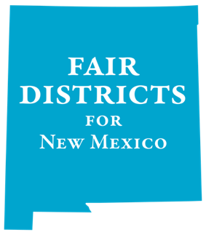
Dick Mason
Kathleen Burke fairdistricts@lwvnm.org
http://www.fairdistrictsnm.org
Facebook: Fair Districts for New Mexico

